CREDIT RISK & LOAN DEFAULT ASSESSMENT TOOL (report)
A Modular Python Application for Automated Applicant Financial Analysis

1. Cover Page
- Project Title: Credit Risk & Loan Default Assessment Tool
- Course Name: Python Programming / Financial Analytics
- Submitted by: Vrinda shrotriya
- Registration Number: 26bce10786
- Institution:vit Bhopal (vityarthi)
- Date: 23rd October 2026

2. Introduction
When banks or lending companies give out loans, they need a reliable way to check if an applicant can pay the money back. Doing these calculations by hand takes a lot of time and can easily lead to human errors.
In this project, I built a Python tool that automates credit risk assessment. It takes basic financial details from an applicant—like their monthly income, monthly debt payments, credit score, and credit limit—and automatically calculates key financial metrics like Debt-to-Income (DTI) and Credit Utilization rates. The system calculates a risk score from 0 to 100, puts the applicant into a risk category (Low, Moderate, or High Risk), and helps decide whether the loan should be approved or rejected.

3. Problem Statement
Many small lending setups or independent credit managers face a few common problems:
- Time-Consuming Manual Work: Calculating ratios like DTI and credit utilization manually using standard spreadsheets takes too much time.
- Human Errors & Inconsistency: Without a standard formula, different people evaluating a loan might assign different risk levels to the same person.
- No Visual Summaries: Spreadsheet logs don't give instant visual feedback or quick charts to analyze applicant risk at a glance.

4. Functional Requirements
My Python application handles the following main tasks:
- Input & Validation: Collects information like income, debt, and credit score while making sure invalid inputs (like negative income or impossible credit scores) are rejected.
- Financial Calculations: Financial Calculations: Calculates DTI ratio by doing (Monthly Debt / Monthly Income) * 100 and Credit Utilization rate by doing (Current Balance / Credit Limit) * 100.
- Risk Score Generation: Uses standard weighted percentages to compute a composite score between 0 and 100.
- Data Storage: Automatically saves applicant details to a JSON file (data/applicants.json) so the data stays saved after closing the program.
- Chart Generation: Uses Matplotlib to plot bar charts comparing the applicant's ratios against safe risk limits.

5. Non-Functional Requirements
- Ease of Use: Has a simple menu-driven terminal interface that guides the user through each step.
- Clean Structure: The code is divided into neat modules (config/, src/, and data/) to keep everything organized.
- Error Handling: Uses try-except blocks so the program doesn't crash if a user types in wrong text or numbers.
- Lightweight: Runs quickly in any standard terminal without requiring heavy setup.

6. System Architecture & How It Works
The project is split into separate parts so the code stays organized. Here is how data moves through the program:
- User Input: The user chooses option 1 from the menu and types in the applicant's financial details.
- Input Validation (preprocessor.py): The program checks if the entries make sense (e.g., preventing negative numbers or credit scores over 850).
- Calculations (risk_calculator.py): The engine calculates the DTI percentage, credit utilization percentage, and a weighted total risk score out of 100.
- Saving Data: The applicant details are written to data/applicants.json.
- Graph Plotting: If requested, Matplotlib pops up a chart displaying the metrics visually.
7. Design Diagrams
To model the application architecture, the system incorporates the following design views:
- Use Case Diagram: Captures primary actor interactions (loan officer executing risk evaluation, viewing records, and generating charts).
- Workflow Diagram: Traces execution flow from user menu selection -> validation -> calculation -> storage -> graph output.
- Sequence Diagram: Displays chronological message passing between app.py, preprocessor.py, risk_calculator.py, and JSON storage.
- Class/Component Diagram: Outlines package structure (config/, src/, data/) and modular function dependencies.
- ER / Schema Design: Defines JSON document key-value structures for storing applicant records.

8. Design Decisions & Rationale
- Why Python? Provides rich native numerical capabilities, clean syntax, and industry-standard analytics libraries.
- Why JSON for Storage? Offers lightweight, human-readable local persistence without requiring complex database server setups.
- Why Matplotlib? Enables instant programmatic generation of clean visualization charts directly from Python scripts.
- Why Modular OOP Design? Decouples input validation from core risk formulas, making the codebase maintainable and extensible.
9. implementation details
- config/settings.py: Holds default formula weights (like 35% weight for DTI and 35% for credit score) and safe threshold values.
- src/preprocessor.py: Handles clean inputs and verifies all numerical ranges before processing.
- src/risk_calculator.py: Contains the formulas for DTI, utilization, and composite risk category assignment.
- app.py: The main menu file that connects all modules together, accepts user commands, and displays the Matplotlib chart.

8. Testing & Results
I tested the program with different inputs to make sure everything worked as expected:
Test Case | Inputs Tested | Expected Outcome | Actual Result
Normal Applicant | Income: $5000, Debt: $1500, Score: 720, Limit: $10000, Bal: $2000 | Low risk score, approved status, chart displays | Passed
Invalid Inputs | Credit Score entered as 950 | Program rejects score and asks user to re-enter | Passed
High Risk Applicant | Income: $3000, Debt: $2000, Score: 580, Limit: $5000, Bal: $4500 | High risk score, rejected status | Passed
Data Persistence | Saved applicant and checked Option 2

9. Results & Output
The program successfully automates credit checks and makes evaluating applicant profiles much faster. Instead of manually calculating ratios in spreadsheets, the script completes all validation, calculation, JSON saving, and graph rendering in just a couple of seconds.

10. Program Execution & Screenshots

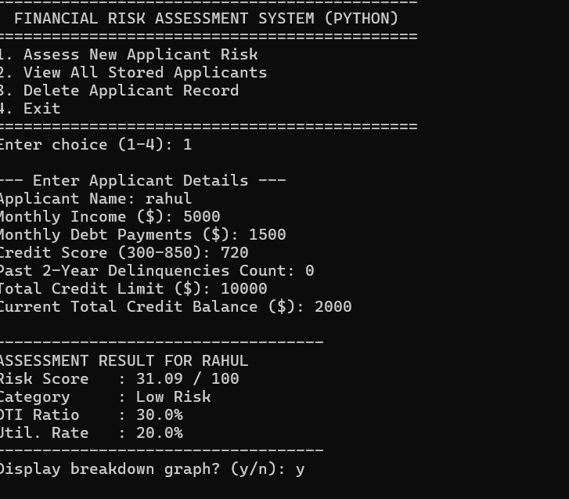

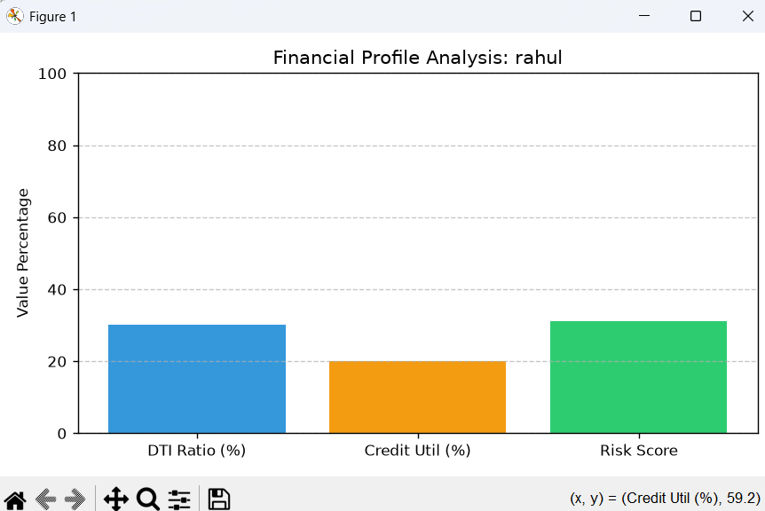

- Screenshot 1: Terminal screen showing the menu and input values.
- Screenshot 2: Pop-up window displaying the Matplotlib chart.
Example Terminal Output: =============================================
FINANCIAL RISK ASSESSMENT SYSTEM (PYTHON)
=============================================
1. Assess New Applicant Risk
2. View All Stored Applicants
3. Delete Applicant Record
4. Exit
=============================================
Enter choice (1-4): 1

--- Enter Applicant Details ---
Applicant Name: Rahul
Monthly Income ($): 5000
Monthly Debt Payments ($): 1500
Credit Score (300-850): 720
Past 2-Year Delinquencies Count: 0
Total Credit Limit ($): 10000
Current Total Credit Balance ($): 2000

--- ASSESSMENT RESULTS ---
Applicant: Rahul
Debt-to-Income (DTI): 30.0%
Credit Utilization: 20.0%
Composite Risk Score: 24.5 / 100
Risk Category: LOW RISK
Status: APPROVED
Record successfully saved to data/applicants.json.

Display breakdown graph? (y/n): y
Rendering visualization chart...

11. Challenges Faced & Fixes
- Module Import Errors: When trying to run py app.py, Python couldn't find subfolders like src. I fixed this by adding blank __init__.py files inside the folders and running the program using py -m app.
- Hidden .txt Extensions: Windows automatically added .txt extensions to files (like app.py.txt), which prevented Python from recognizing them. I used PowerShell commands (Rename-Item) to fix the extensions.

12. Future Improvements
- Add a web interface using Flask or Streamlit so users don't have to use the terminal.
- Connect the application to a real database like SQLite instead of relying on a single JSON file.
- Implement machine learning models to predict risk levels based on past loan data.

13. What I Learned
- How to structure a Python project neatly across separate folders (config, src, data).
- How to write input validation routines to prevent program crashes.
- How to work with Matplotlib to generate charts and save output data into JSON files.

14. References
- Python Official Documentation: https://docs.python.org/3/
- Matplotlib Documentation: https://matplotlib.org/
- Consumer Financial Protection Bureau (CFPB) guidelines on Debt-to-Income ratios.

15. Source Code & Links
- GitHub Repository: [Insert your GitHub link here, or remove this line if not needed]
- Main Code File: app.py
- Data File: data/applicants.json

